Web Development Lesson Plan

|  |  |  |
| --- | --- | --- |
| Session: 1 | Topic: The Internet - Background | Day: 1 |

|  |
| --- |
| Lesson Objective:  This exercise will...   * Cover web development standards and background   The purpose of this lesson is also that   * Students can identify ways in which web applications are designed and created. |
| Materials Needed:   * Internet access * Web browser |
| Agenda:   1. How the internet works (30 minutes) 2. Website vs web application (10 minutes) 3. Web frameworks (10 minutes) 4. Reflection (5 minutes) |
| Procedure:  Student can do this fully independently by reading the instructions, or someone can read the instructions to make sure the task is understood before doing the activity. The reflection part can be done with guided instructions, or in pairs with other students if available to compare notes. |
| Assessment/Check for learning:   * Students can identify concrete things that they missed in their observation (note that this is not a bad thing, the purpose of this lesson is to realize that intentionally looking for information comes with the ‘penalty’ of reduced attention to other things. |

What if:

* Student has already shown proficiency in that skill?
  + Pick a movie or episode in which a lot of things are happening, so that there are more things for the student to keep track of.
* Student is having a hard day and needs special accommodations?
  + Pick a movie or episode in which only a few things are happening, so that there are less things for the student to keep track of.
  + Instead of writing, the student can also take spoken notes with an audio recorder. This will be a bit trickier in the second part but audio in the movie can be supported with subtitles.

NOTES:

* Duration is approximately 50 minutes; can be adjusted by shortening the duration of the film clip. Less than 10 minutes is not recommended unless necessary.

**Instructions**

**How the internet works (30 minutes)**

Step 1:

The internet has been around since the late 1960’s. Despite many changes and new terminology, the internet remains essentially the same. At its core, the internet is a collection of computers that can communicate with each other. Watch the following video to learn about the history of the internet:

[History of the Internet](https://www.youtube.com/watch?v=9hIQjrMHTv4)

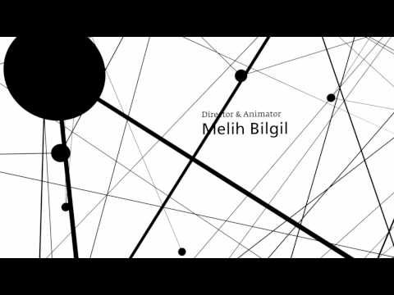

Step 2:

Now that you have learned how the internet began you will learn how the internet works today. Watch the following video to learn about how the internet works:

[The Internet: Crash Course Computer Science #29](https://www.youtube.com/watch?v=AEaKrq3SpW8)

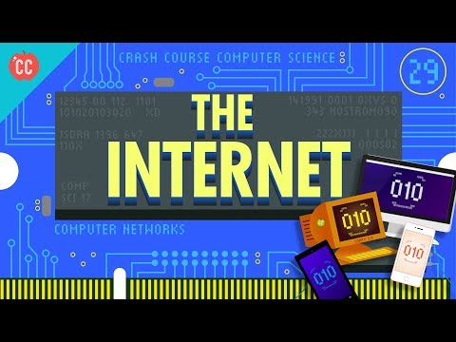

Step 3:

Now that you know how the internet works you will learn what the world wide web is. This is different from the internet. The world wide web lives within the framework of the internet. Watch the following video to understand how the world wide web and internet work together:

[The World Wide Web: Crash Course Computer Science #30](https://www.youtube.com/watch?v=guvsH5OFizE)

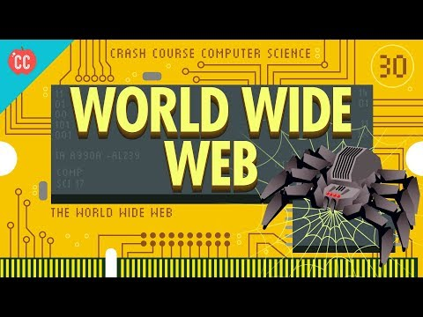

Note: You do not need to take notes, the information provided by the video is supplementary to your understanding of how the internet works.

**Website vs web application (10 minutes)**

Step 1:

Before you dive into the world of web development using the Django framework we will first touch on web development background. To begin, webpages are as abundant as grains of sand, but not every webpage is the same. Some webpages are very simple, and only display text and a few graphics. Other webpages are complex and do many functions, such as Amazon’s E-commerce webpage. Simple webpages that display text or images are referred to as websites. Complex webpages that display text, images, and capture or display complex data are referred to as web applications.

Step 2:

Read the following article to further understand the difference between websites and webapps:  
<https://medium.com/@essentialdesign/website-vs-web-app-whats-the-difference-e499b18b60b4>

**Web Framework (10 minutes)**

Step 1:

To make it easier to build webapps it is common to use a web framework. A web framework is a code management tool that aids web developers by automating repetitive tasks and managing code. Read the following article to learn more about web frameworks:

<https://welearncode.com/what-are-frontend-frameworks/>

**Reflection (5 minutes)**

After watching the videos, what is one thing that you did not know about the internet or the world wide web?

In the following lessons you will learn how to create your very own website and a simple web application. The lessons will cover the Django Framework, HTML, and CSS. The lessons will build upon each other.